Trade Match

Instrumentation

Overview:
This document describes the current and future plans for instrumentation for CTM-I. Instrumentation is a feature available with the Foundation Framework (FF). A core set of services are available for instrumentation through FF. The instrumentors can be visually monitored with the System Health Monitor (SHM). The types of instrumentors currently supported by FF are Queue, Thread Pool, Method, Network, Heap, Count and Event Channel.

Two sets of Instrumentors are currently implemented in CTM-I. In the Web Server, every call to an Action class is instrumented. In the Application Server, every call to a method on a service is instrumented.

In the futures, the API server should contain instrumentation to instrument the connections to the firms. This can be done by attaching a Queue Instrumentor and a Network instrumentor to each Firm connection.

Action Instrumentation
The instrumentation in the Web server is coded in the class “com.cboe.ctmi.action.CTMIBaseAction”. The code for setting up the instrumentation is below.

public abstract class CTMIBaseAction extends Action
{
<Unrelated code Deleted>
public final ActionForward execute(ActionMapping mapping,
ActionForm form,
HttpServletRequest request,
HttpServletResponse response)
throws Exception
{

ActionForward actionForward;

String ipAddress = request.getRemoteAddr();

MethodInstrumentor methodInstrumentor = getMethodInstrumentor(ipAddress,request.getSession().getId());

methodInstrumentor.incCalls(1);
methodInstrumentor.beforeMethodCall();
try
{
<Unrelated code Deleted>
actionForward = ctmiExecute(mapping,form,request,response);
}
catch (Exception e)
{
methodInstrumentor.incExceptions(1);
throw e;
}
finally
{
methodInstrumentor.afterMethodCall();
}

return actionForward;
}
protected MethodInstrumentor getMethodInstrumentor(String hostAddress,String sessionID)
{
MethodInstrumentor methodInstrumentor = null;

StringBuffer instrumentorName = new StringBuffer();
instrumentorName.append(getActionName());
instrumentorName.append("/");
instrumentorName.append(hostAddress);
if (sessionID != null && !sessionID.equals(""))
{
instrumentorName.append("/");
instrumentorName.append(sessionID);
}
methodInstrumentor = InstrumentorHome.findMethodInstrumentorFactory().find(instrumentorName.toString());

if (methodInstrumentor == null)
{
try
{
methodInstrumentor = InstrumentorHome.findMethodInstrumentorFactory().create(instrumentorName.toString(), new InstrumentorUserData());
InstrumentorHome.findMethodInstrumentorFactory().register(methodInstrumentor);
}
catch (InstrumentorAlreadyCreatedException e)
{
CTMILog.exception(LogCategory.APPLICATION_SUPPORT,"CTMIBaseAction cannot register Method Instrumentor for action",e);
}
}

return methodInstrumentor;
}

/**
* Method used to get the name of the action. This name is used in instrumentation.
* @return
*/
protected abstract String getActionName();
}

The name of the Action Instrumentor is setup to be able to uniquely identify the performance of a single session. The name is configured as “<ActionName>/<IP Address of Client Machine>/<Client Session ID>. A sample name is “TradeEntryAction/170.137.73.55/2eve6artt65hf”.

A sample screenshot from the System Health Monitor showing the Method Instrumentors for the Action Instrumentation is below.
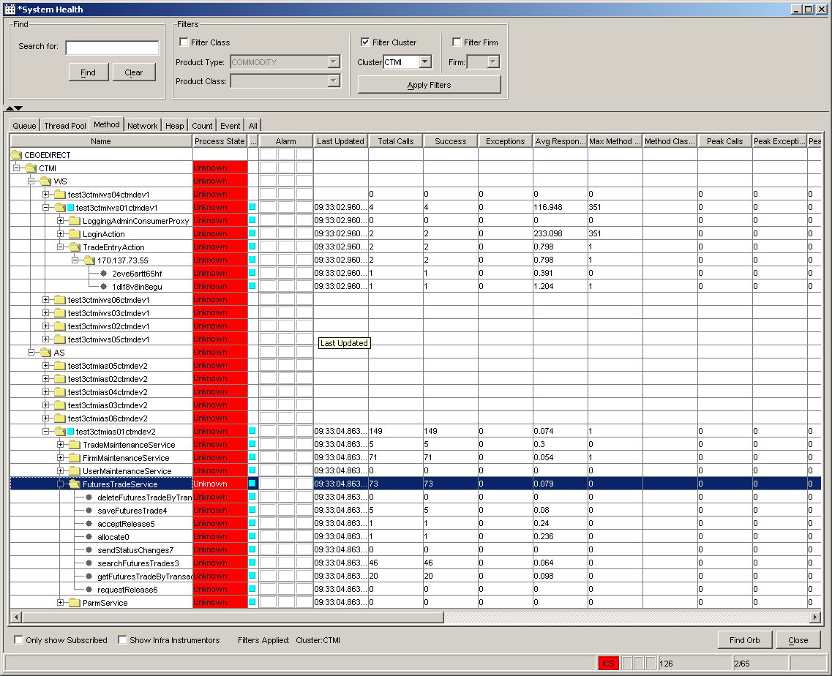

Service Method Instrumentation
The methods on the services in the application server are all instrumented. The instrumentation is done by the interceptors before any CTM-I code is executed. There is nothing that needs to be done in the CTM-I code for service method instrumentation. See samples of the instrumentors in the screenshot above.

API Server Instrumentation
When the API Server is created it should be setup with a couple types of instrumentation. The current connection monitor should be replaced with instrumentation. Two types of instrumentors could be used to create all the needed data. The Network Instrumentor can be setup to monitor a network connection. One network instrumentor should be setup and maintained for each connection. Below is a screenshot from the SHM showing some network instrumentors. This data should easily replace the existing monitor.
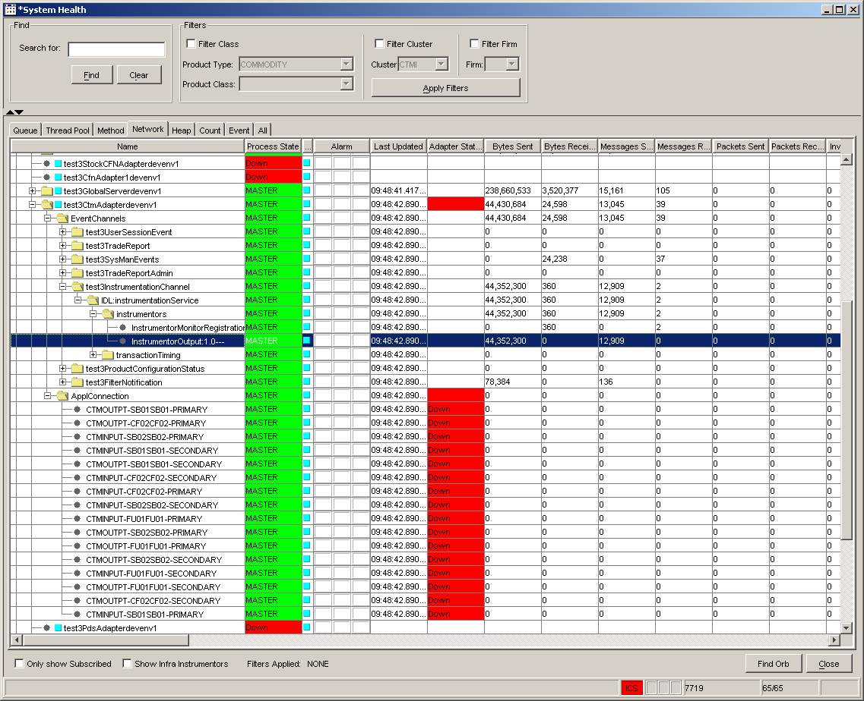

Below is a screenshot of some queue instrumentors and how they display.
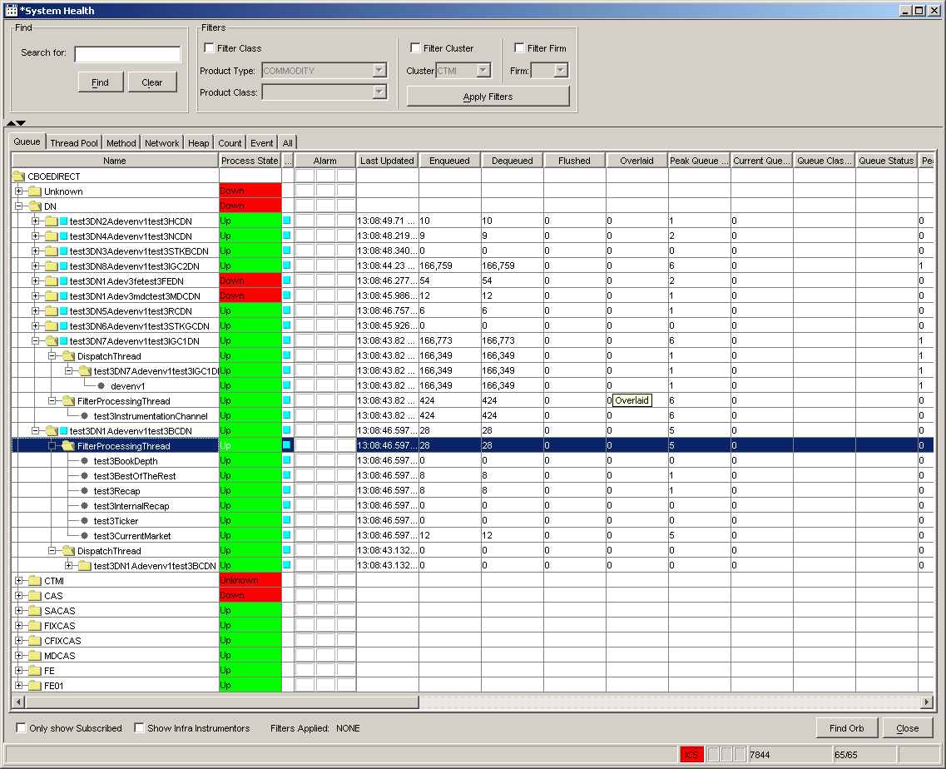

Alarms
One of the recent features of the System Health Monitor is the ability to set alarms. Alarms can be set on any type of instrumentor. Also, multiple conditions on multiple instrumentors can be the trigger for the alarm. More training on the Alarms will have to be done by the CBOEDirect GUI team. The theory was that you could do something like put an alarm on the instrumentor that monitors the API Server connection with FOC and produce a warning if the Queue size is greater than 1000 and produce a critical alarm if the Queue size is greater than 2000.

System Health Monitor
The System Health Monitor is an application developed and maintained by the GUI group for CBOE Direct. The current manager of the GUI team is Alex Brazhnichenko. To get the current version of the monitor installed, contact Alex and ask for an install. See the System Health Monitor User Guide for help on the monitor.

